**Lab No: 7**

### Title: Compare Double-Sideband and Single-Sideband Amplitude Modulated Signal using Matlab

(Create and Explore the dsp.SpectrumAnalyzer object and set its properties.)

Provide .m file with detailed comments

**ssbmod [Single sideband amplitude modulation]**

Syntax

y = ssbmod(x,Fc,Fs)

y = ssbmod(x,Fc,Fs,ini_phase)

y = ssbmod(x,fc,fs,ini_phase,'upper')

Description:

y = ssbmod(x,Fc,Fs) uses the message signal x to modulate a carrier signal with frequency Fc (Hz) using single sideband amplitude modulation in which the lower sideband is the desired sideband. The carrier signal and x have sample frequency Fs (Hz). The modulated signal has zero initial phase. y = ssbmod(x,Fc,Fs,ini_phase) specifies the initial phase of the modulated signal in radians.y = ssbmod(x,fc,fs,ini_phase,'upper') uses the upper sideband as

the desired sisedband.

**ssbdemod [Single sideband amplitude demodulation]**

Syntax :

z = ssbdemod(y,Fc,Fs)

z = ssbdemod(y,Fc,Fs,ini_phase)

z = ssbdemod(y,Fc,Fs,ini_phase,num,den)

Description:

For All Syntaxes z = ssbdemod(y,Fc,Fs) demodulates the single sideband amplitude modulated signal y from the carrier signal having frequency Fc (Hz). The carrier signal and y have sampling rate Fs (Hz). The modulated signal has zero initial phase, and can be an upper- or lower-sideband signal.

Tasks:

1. Set the sampling frequency to 100 Hz and carrier frequency to 10 Hz. Generate a time vector having a duration of 100 s.

fs = 100; % Sampling Frequency

fc = 10; % Carrier Frequency

t = (0:1/fs:100)';

1. Create single tone sinusoidal signal 1 Hz Signal

x = sin(2*pi*t);

1. Carrier Signal

yc = sin(2*pi*fc*t);

1. Plot the modulating Signal and Carrier Signal

figure;

plot(t,x,'r',t,yc,'b--')

xlabel('Time (s)')

ylabel('Amplitude')

legend('Original Signal','Carrier Signal')

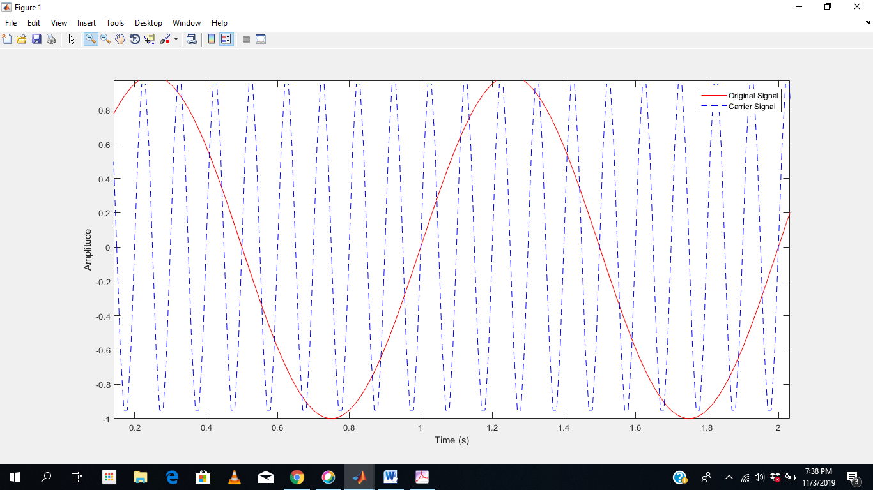

Figure 1: Modulating and Carrier Signal

1. Modulate x using single- and double-sideband AM.

ydouble = ammod(x,fc,fs);

lowerSidebandSignal = ssbmod(x,fc,fs);

upperSidebandSignal = ssbmod(x,fc,fs,0,'upper');

1. Create a spectrum analyzer object to plot the spectra of the two signals. Plot the spectrum of the double-sideband signal.

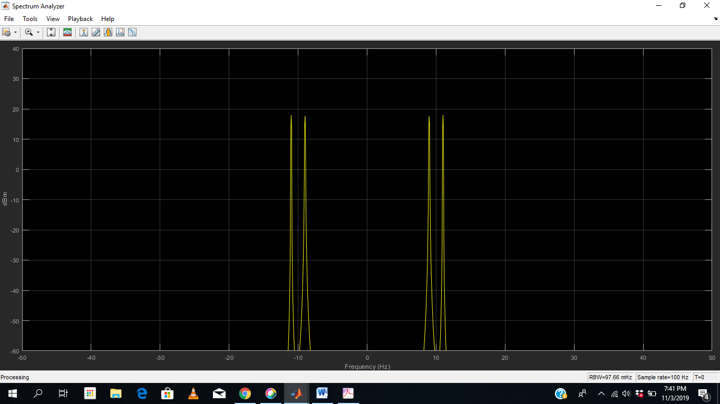

1. Create a spectrum analyzer object to plot the spectra of the lower sideband signals. Plot the spectrum of the single-sideband signal.

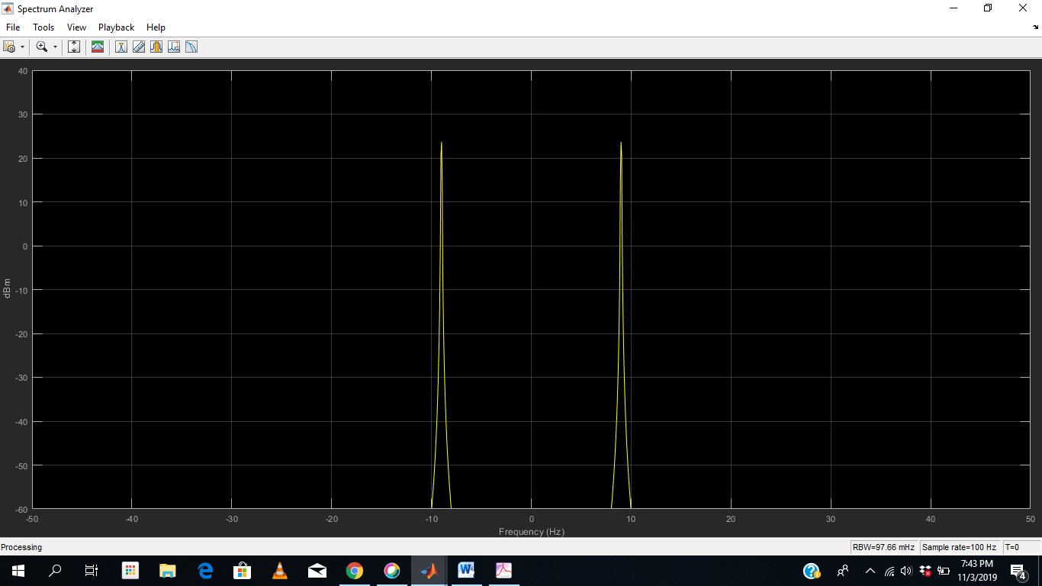

1. Create a spectrum analyzer object to plot the spectra of the upper sideband signals. Plot the spectrum of the single-sideband signal.

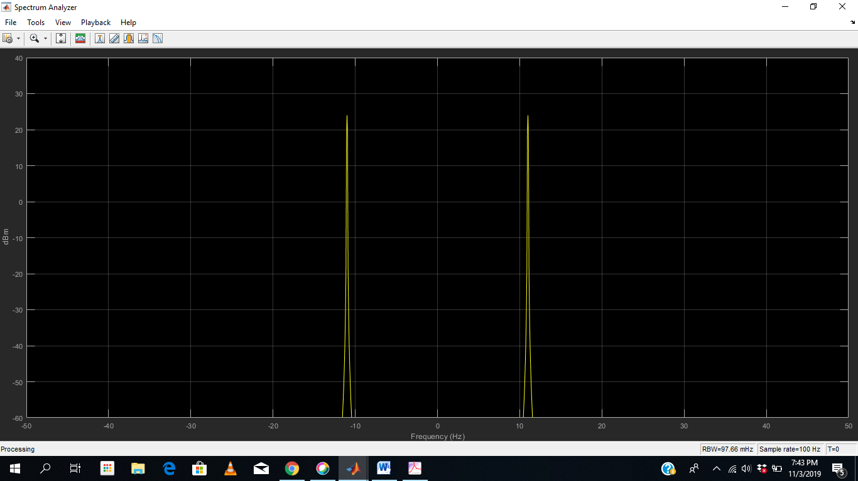

1. Demodulate the lower and upper sideband signals.

s1 = ssbdemod(lowerSidebandSignal,fc,fs);

s2 = ssbdemod(upperSidebandSignal,fc,fs);

1. Compare processed signals with original and verify reconstruction.
2. plot(t,x,'k',t,s1,'r:',t,s2,'g-.');
3. legend('Original Signal','Demodulation of Lower Sideband','Demodulation of Upper Sideband');

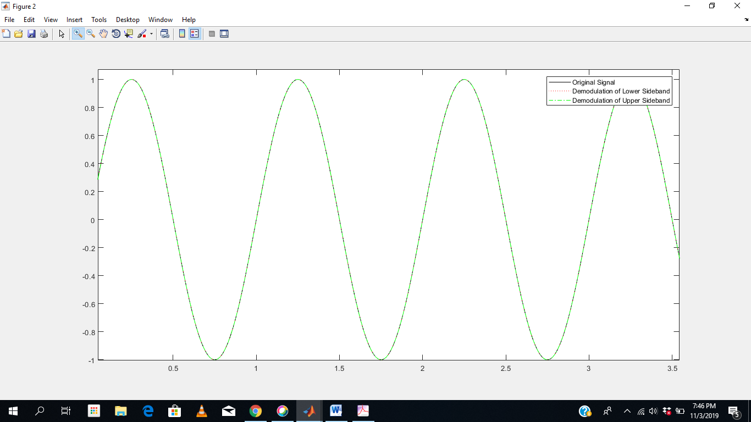

**Answer the following Questions**

Create and Explore the dsp.SpectrumAnalyzer object and set its properties.)

1. Plot (Analyze the spectrum in terms of Power Density) the Power density
2. Plot both the Spectrum and Spectrogram
3. Plot the Spectrum chose Spectrum Unit as dBW, dBm, and Watts.